(Toastmaster) <http://www.linkedin.com/company/13845?trk=tyah&trkInfo=clickedVertical%3Acompany%2CclickedEntityId%3A13845%2Cidx%3A2-1-2%2CtarId%3A1457515040123%2Ctas%3Atoast>

Python excel read and write

<http://www.cnblogs.com/lhj588/archive/2012/01/06/2314181.html>

xpath 路径表达式

<http://www.ruanyifeng.com/blog/2009/07/xpath_path_expressions.html>

python 异常处理

<http://www.cnblogs.com/fnng/p/3518202.html>

重定向培训

<http://itest.info/courses/2>

python xlrd 安装

<http://huaxia524151.iteye.com/blog/1173828>

python 基础教程

<http://www.runoob.com/python/python-tutorial.html>

javascript

<http://www.cnblogs.com/pchmonster/p/4769840.html>

古筝手型

<http://www.gzyuan.com/news/205.html>

w3school

<http://www.w3school.com.cn/>

读书推荐

<http://www.book110.com/1168.html>

中国日报网

<http://www.chinadaily.com.cn/>

AMT

Login

<https://w3-01.sso.ibm.com/tools/wse/runtime/sit/protect/digsalestech/dev_mart/W3/login.wss>

UAT

<https://w3-01.sso.ibm.com/tools/wse/runtime/uat/protect/digsalestech/AdminRole/SearchExport.wss>

RTC

<https://ratsuite183.sby.ibm.com:9444/ccm/web/projects/eApproval%20-%20WSE%20-%201873#action=com.ibm.team.dashboard.viewDashboard>

eApproval

login

<https://w3-01.sso.ibm.com/tools/wse/runtime/sit/protect/eapproval/dev/W3/IBMdmin/login.wss>

RTC

<https://ratsuite183.sby.ibm.com:9444/ccm/web/projects/eApproval%20-%20WSE%20-%201873#action=com.ibm.team.dashboard.viewDashboard>

WSE请假

<https://g01aciwascl017.ahe.pok.ibm.com/tools/wse/runtime/test/protect/isp/V1/WWW/Requester/login.wss>

WSE connection

<https://w3-connections.ibm.com/wikis/home?lang=en-us#!/wiki/Wabcb483886a2_470b_a640_c79ac113a9b1/page/Selenium%20&%20Node.js>

WSE sharing activity

<https://w3-connections.ibm.com/activities/service/html/mainpage#activitypage,94f4c662-2575-4808-bd71-07bf3435eb42>

Agile taste

<http://calmedia.atlanta.ibm.com/agile_academy/courses/taste_of_agile/index.php?id=4378286023001&auto=true>

Auto testing activity

<https://w3-connections.ibm.com/activities/service/html/mainpage#activitypage,7ecb122e-d279-4ee8-b959-a7cb7b76a702>

Share wiki

<https://w3-connections.ibm.com/wikis/home?lang=en-us#!/wiki/Wabcb483886a2_470b_a640_c79ac113a9b1/page/Python>

OMM RTC

<https://ratsuite183.sby.ibm.com:9444/ccm/web/projects/OMM%20-%20Online%20Maintenance%20Management%20%28Development%29#action=com.ibm.team.dashboard.viewDashboard>

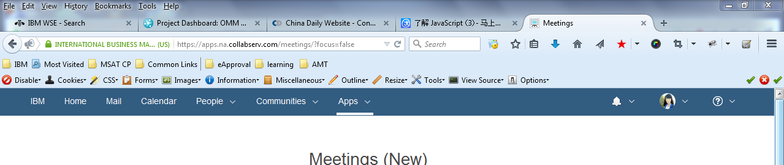

Skype ~~amrita19882

Linkedin [281011390@qq.com](mailto:281011390@qq.com) Win2002

Js编辑器 webstorm

VNC 4444447

eSign <https://w3-01.sso.ibm.com/tools/wse/runtime/sit/protect/esign/dev/login.wss>

PublicCsutomer

<https://w3-01.sso.ibm.com/tools/wse/runtime/sit/public/esign/dev/WWW/Customer/PublicProposalSearch.wss?CountryCode=AR&BrandCode=ARbrand>

RTC

<https://ratsuite183.sby.ibm.com:9444/ccm/web/projects/eSign%20-%20WSE%20-%201869#action=com.ibm.team.dashboard.viewDashboard&tab=_1>

eSal

<https://ratsuite183.sby.ibm.com:9444/ccm/web/projects/eSign%20-%20WSE%20-%201869#action=com.ibm.team.dashboard.viewDashboard&tab=_1>

SIT

<https://w3-01.sso.ibm.com/tools/wse/runtime/sit/protect/esal/NorthStar/W3/Admin_Homepage.wss>

GIT

<http://www.liaoxuefeng.com/wiki/0013739516305929606dd18361248578c67b8067c8c017b000/001373962845513aefd77a99f4145f0a2c7a7ca057e7570000>

<https://github.com/>

Printer

|  |
| --- |
| [**http://w3-03.ibm.com/tools/print/index.html**](http://w3-03.ibm.com/tools/print/index.html) |